**INPUT**

1. **SUM OF DIGIT**

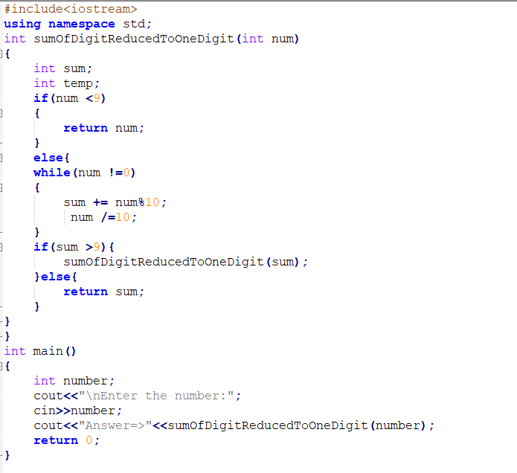

**OUTPUT**

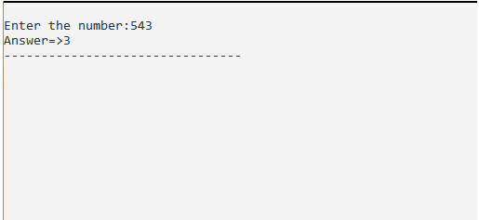

1. **FUNTION WITH RETURN TYPE**

**INPUT**

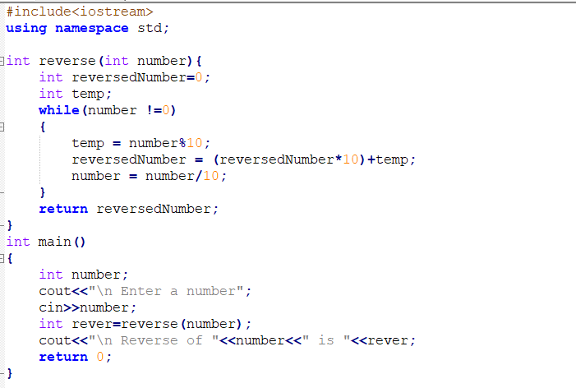

**OUTPUT**

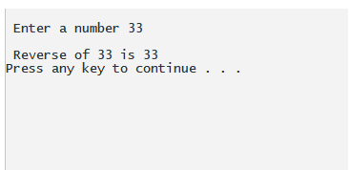

1. **FUNTION WITHOUT RETURN TYPE**

**INPUT**

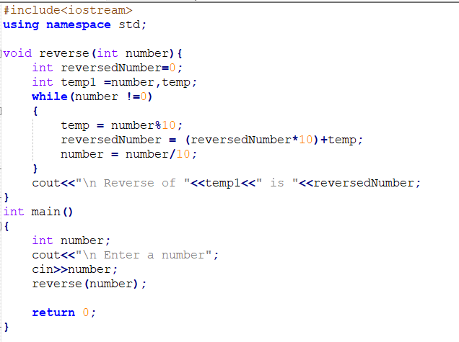

**OUTPUT**

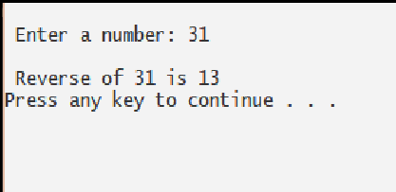

1. **PASS BY VALUE PASS BY ADDRESS PASS BY POINTER**

**INPUT**

PASS BY VALUE

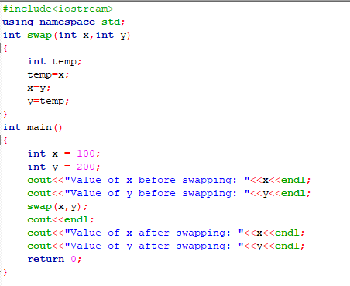

**OUTPUT**

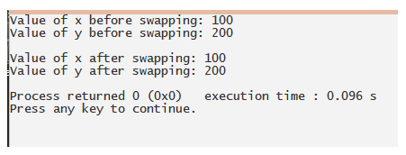

**INPUT**

PASS BY ADDRESS

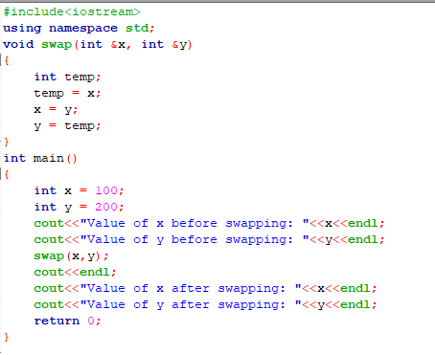

**OUTPUT**

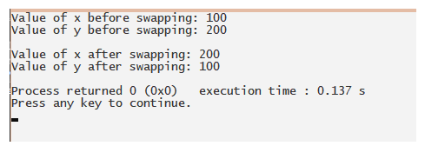

**INPUT**

PASS BY POINTER

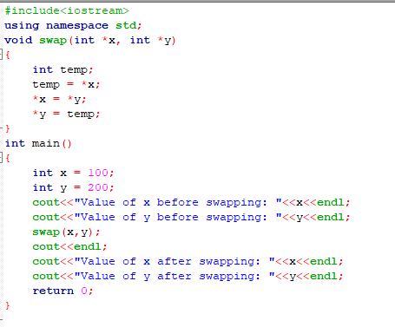

**OUTPUT**



1. **VOLUME OF BOX USING DEFAULT ARGUMENT**

**INPUT**

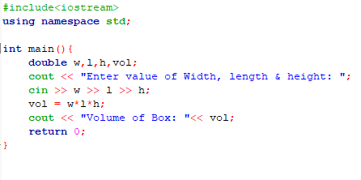

**OUTPUT**

